

Capstone Project Phase A
ThrivePath - Overcoming FTT Through Innovation.

PROJECT CODE:
25-1-D-17
Supervisor:
Dr. Natali Levi-Soskin

Authors:
Kfir Sharoni, ID: 206013559
KfirSharoni1@gmail.com
Avishay Halifa, ID: 209404425
AvishayHalifa@gmail.com‬
GitHub Repository

Table of Contents
1. Abstract 3
2. Introduction 4
3. Background and related work 6
3.1 FTT definition 6
3.2 FTT Consequences 7
3.3 Existing treatment 8
3.4 OPM 11
4. Expected Achievements. 12
5. Engineering Process 13
5.1 Process 13
5.2 Product 19
5.2.1 UML Diagrams 28
5.2.2 System Architecture Overview 30
5.2.3 Prototype 31
6. Verification plan 35
7. Expected challenges 36
8. Use of AI Tools 37
9. REFERENCES: 38

1. Abstract
Failure to Thrive (FTT) is a significant pediatric health concern that impacts a child's physical, cognitive, and emotional development. Current solutions for addressing FTT are often fragmented, lacking a comprehensive and integrated approach to effective intervention. This project introduces ThrivePath, a digital platform designed to provide personalized, evidence-based recommendations to support children diagnosed with FTT. The platform enables caregivers to input the child’s physical measurements and upload diagnostic data, which are analyzed to generate customized meal plans, supplement recommendations, and lifestyle modifications tailored to each child’s needs. By incorporating Object-Process Methodology (OPM) and leveraging AI-driven decision-making, ThrivePath bridges the gap between medical, psychological, and nutritional guidance, ensuring a holistic approach to managing FTT. The system enhances accessibility, usability, and collaboration among caregivers and healthcare professionals, offering a centralized hub for managing FTT interventions effectively. Our solution aims to empower families with actionable insights, improve patient outcomes, and streamline FTT management through an intuitive, technology-driven approach.
Keywords: Failure to Thrive (FTT), Pediatric health, Holistic approach, Personalized healthcare, Nutritional guidance, Digital health platform, AI-driven recommendations, Growth tracking, Child development.

2. Introduction
Failure to Thrive (FTT) represents a critical pediatric health challenge that significantly impacts child development and long-term health outcomes. This condition, characterized by inadequate physical growth and potential developmental delays, requires comprehensive, multifaceted interventions that address nutritional, environmental, and physiological factors ‎[1].
Contemporary approaches to addressing Failure to Thrive encompass a multifaceted medical and supportive framework. Clinical interventions primarily focus on comprehensive medical diagnostics, including detailed pediatric assessments, systematic growth monitoring, and identifying underlying physiological conditions ‎[2][‎3]. Nutritional strategies involve specialized dietary recommendations, targeted supplementation, and calorie-dense nutritional plans tailored to individual child needs. Healthcare professionals employ interdisciplinary approaches, integrating pediatric nutritionists, developmental specialists, and social workers to provide holistic care. Technological advancements have introduced digital tools like growth tracking applications, telemedicine platforms, and online nutritional resources, enhancing accessibility and monitoring capabilities [‎3]. Family-centered interventions include parental education programs, feeding technique workshops, and guided nutritional counseling, empowering caregivers with practical skills and knowledge. Despite these comprehensive strategies, existing solutions often remain fragmented, complex, and challenging to navigate, creating a critical need for more integrated, user-friendly support systems that can effectively address the nuanced challenges of childhood growth and development [‎1][‎2].
Websites are essential tools in healthcare as they provide a cost-effective and accessible platform for sharing evidence-based information with both professionals and consumers. They help bridge knowledge gaps, empower individuals to make informed health decisions, and support better practices among healthcare providers. In a rapidly evolving healthcare landscape, websites address challenges such as increasing demand for services, resource constraints, and the need for timely information, making them indispensable in modern health management [‎10].

We aim to develop a website that will serve as a centralized platform to integrate existing solutions for addressing the challenges associated with Failure to Thrive (FTT) in children. Our solution seeks to bridge the gap between diagnosis and intervention by offering personalized recommendations based on diagnostic data.
Users will be able to upload diagnostic reports or documents detailing the child's FTT condition onto the website. Utilizing this information, the platform will analyze the data and provide tailored solutions that may contribute to the child's growth. These solutions may include customized meal plans, suggested vitamins or supplements, and other practical interventions designed to address the child's specific needs.
The stakeholders for the proposed solution include parents and caregivers, pediatricians, pediatric nutritionists, social workers, developmental specialists, technology developers, and, most importantly, children with Failure to Thrive (FTT). Parents and caregivers will benefit from simplified access to tailored recommendations, empowering them with actionable insights to support their child's growth [‎1][‎2]. Pediatricians and healthcare professionals will find the platform a valuable tool to complement their expertise, saving time and improving care delivery. Nutritionists and dietitians will benefit from streamlined planning and expanded reach, while social workers and developmental specialists can use the platform to address psychosocial and developmental factors more effectively [‎1][‎2]. Technology developers and researchers gain a real-world application for their tools, promoting innovation in digital healthcare. Ultimately, children with FTT will benefit from timely, personalized, and comprehensive interventions that support their growth and overall well-being. By addressing the unique needs of each stakeholder, the solution fosters collaboration, reduces care fragmentation, and ensures better outcomes for children with FTT [‎1][‎2].
The structure of this document is organized to provide a thorough and systematic overview of the project. Section two Background and related work examines foundational research related to addressing Failure to Thrive (FTT), critically evaluates existing solutions, and highlights gaps within them. Further, in section 3 we demonstrate the Expected Achievements which articulates the anticipated outcomes of the project, focusing on innovative features and the potential to enhance care for children with FTT. The Process, in section 4 details the methodologies employed in the project, including data analysis, technological implementation, and iterative development, while also addressing strategies used to overcome encountered challenges. Finally, the Testing and Evaluation section provides a comprehensive plan for testing the program, including a detailed description of the test plan, the constraints and assumptions considered, and the specifications of the testing environment, ensuring the reliability and effectiveness of the solution.

3. Background and related work

3.1 FTT definition
Medical definition
Failure to Thrive (FTT) is a clinical term used to describe children whose growth and development do not meet expected standards. Medically, it is often diagnosed when a child's weight-for-age measurement falls below the 3rd percentile on multiple occasions or when there is a significant deceleration in growth across two major percentiles on a growth chart. This condition reflects inadequate caloric intake, absorption, or excessive caloric expenditure, which ultimately affects the child's nutritional status and overall health. The World Health Organization (WHO) growth charts are commonly used to identify FTT, emphasizing weight-for-length ratios and weight velocities to assess nutritional deficits accurately. These tools provide critical insights into growth trends, enabling early intervention [‎2][‎3].
Types of FTT: Organic and Non-Organic
- Organic FTT
Organic FTT stems from underlying medical conditions such as chronic illnesses, metabolic disorders, genetic abnormalities, or malabsorption syndromes like celiac disease or cystic fibrosis. These conditions directly affect the child's ability to grow and gain weight. For example, children with congenital heart disease or hyperthyroidism often have increased caloric requirements due to their medical condition, which can lead to excessive caloric expenditure. Early medical evaluation and targeted interventions are crucial for managing organic FTT effectively [‎1][‎2].
- Non-Organic FTT
Non-organic FTT is associated with environmental or psychosocial factors, such as neglect, poor feeding practices, or caregiver-related issues like mental health disorders or insufficient knowledge about proper nutrition. This type of FTT often highlights the interplay between a child's growth patterns and the quality of care provided by their family or social environment. It is also more prevalent in economically disadvantaged populations, where access to adequate nutrition and healthcare may be limited. Non-organic FTT is sometimes referred to as reactive attachment disorder when psychosocial factors significantly influence the child's growth [‎1][‎2][‎4].

3.2 FTT Consequences
The effects of FTT extend beyond immediate physical health, profoundly impacting cognitive, emotional, and behavioral development. Nutritional deficiencies during critical growth periods can lead to delays in motor skills, impaired immune response, and poor academic performance. Children with prolonged FTT often exhibit behavioral issues such as irritability, lack of focus, or social withdrawal. The long-term effects may also include stunted growth and reduced intellectual capacity, underscoring the need for early and comprehensive interventions [‎2][‎3][‎4].
Prevalence and Demographics of FTT
FTT affects 5-10% of children in primary care settings in the United States and approximately 3-5% in hospital settings. The prevalence is higher in socioeconomically disadvantaged communities, where access to adequate nutrition and healthcare resources is limited. Most cases of FTT are identified before the age of 18 months, a period critical for growth and development [‎2][‎3].
Impact on Children
Failure to Thrive (FTT) can have profound effects on children, influencing their physical, cognitive, and emotional development. Physically, children with FTT may experience slowed growth, delayed milestones, and weakened immunity due to inadequate nutrition. These issues can lead to frequent illnesses and hospitalizations, further hindering their development. Cognitively, FTT is associated with delayed brain growth, which can impact learning and academic performance later in life. Emotionally, affected children may struggle with forming secure attachments, particularly if feeding difficulties create stress in parent-child interactions [‎2].

Impact on Families
Failure to Thrive (FTT) significantly impacts families, creating stress and emotional strain as they navigate the challenges of managing their child’s nutritional needs and growth. Parents often experience guilt, frustration, and self-doubt, particularly when facing feeding difficulties or frequent medical appointments. Financial burdens and disruptions to daily life further exacerbate the situation, especially when FTT is linked to neglect or abuse, requiring legal or social interventions. The condition can also affect the child’s cognitive and emotional development, adding to the family’s long-term responsibilities. Multidisciplinary support, including nutritional counseling and home visits, can improve outcomes for both the child and the family, helping to alleviate some of these challenges [2].
Shifts in Percentiles of Growth During Early Childhood
- Birth to 6 Months: The most significant shifts occur during this phase due to rapid and variable growth. For example, 61.8% of children shifted two major percentiles in weight-for-height, 38.8% in weight-for-age, and 31.9% in height-for-age.
- 6 to 24 Months: Growth begins to stabilize, with 20-27% of children shifting percentiles in weight-for-height and 6-15% in weight-for-age.
- 24 to 60 Months: Shifts are least common, reflecting greater growth stability. Only 6-15% shifted in weight-for-height and 1-5% in weight-for-age.
These trends highlight the dynamic nature of growth in infancy and early childhood, gradually stabilizing as children age [‎5].

3.3 Existing treatment
Treating Failure to Thrive (FTT) involves significant challenges due to the multidisciplinary nature of care, requiring the coordination of medical, nutritional, and psychological interventions. Physicians often focus on identifying and treating underlying medical conditions such as gastrointestinal disorders or infections, using clinical expertise and evidence-based guidelines to guide their decisions. Nutritionists, on the other hand, emphasize tailored dietary plans to address nutrient deficiencies, which may conflict with medical treatment plans if the patient's condition limits their ability to tolerate certain foods​. Psychological factors add another layer of complexity. Family dynamics and caregiver behaviors can contribute to FTT, making psychological counseling critical for addressing feeding practices or underlying stressors. However, psychological recommendations may sometimes clash with rigid medical protocols or dietary restrictions, creating tensions in integrated care​​ [‎6][‎7].
These conflicts underscore the importance of collaboration among healthcare providers, as each discipline brings a distinct perspective that must be reconciled to achieve optimal outcomes. Effective interdisciplinary communication and comprehensive care planning can help streamline efforts, align treatment plans, minimize conflicts, and improve the quality of care​​ [‎8][‎9].
Medical Treatment:
Pharmacological approaches are generally reserved for cases with underlying medical conditions that impede growth. Medications may include supplementation of growth hormones for children with growth hormone deficiencies or enzyme replacements for metabolic disorders like cystic fibrosis. For instances of chronic inflammation or infection contributing to FTT, appropriate antibiotic or anti-inflammatory medications are crucial. It is essential to individualize treatment based on the root cause of FTT, as indiscriminate use of drugs like appetite stimulants (e.g., cyproheptadine) has limited evidence of efficacy outside specific contexts​​. However, this approach is not sufficient on its own because it addresses only the medical causes of FTT while potentially neglecting nutritional and psychosocial factors, which often play a critical role in the condition's development and resolution [‎2][‎4].
Nutritional Treatment:
Nutritional interventions are a cornerstone in the management of FTT, aiming to provide sufficient calories and nutrients to support growth. This can involve adjusting the diet to include energy-dense foods or fortified formulas for t. For older children, strategies might include small, frequent meals with calorie-rich additions, such as adding oils, butter, or nutritional supplements. In severe cases, tube feeding or parenteral nutrition may be necessary. Regular follow-ups are crucial to monitor growth progress and adapt dietary plans as needed. However, nutritional interventions alone may not be sufficient, as they primarily focus on caloric intake without addressing underlying medical or psychosocial contributors to FTT, which could limit their long-term effectiveness ​[4].
Psychological Treatment:
Psychological support plays a vital role in addressing FTT, especially when psychosocial factors are significant contributors. Family counseling is often employed to enhance feeding practices, address caregiver stress, and foster healthier parent-child interactions. Behavioral therapies may be used for children who exhibit feeding aversions or refusal. A multidisciplinary approach involving psychologists, social workers, and pediatricians has proven effective in improving not only the child’s growth but also the family’s overall dynamic. Left unaddressed, the psychosocial aspects of FTT can lead to long-term consequences, including developmental delays and behavioral challenges, underscoring the importance of early intervention. Nevertheless, psychological treatment alone may fall short because it does not directly address nutritional deficits or medical conditions that could be driving FTT, thereby necessitating a comprehensive and integrative approach [‎2].
Support Systems:
Support systems for children with FTT and their families include both in-person and community-based resources. Examples include:
- Home Nursing Visits: These visits provide a personalized approach to assess feeding techniques, environmental conditions, and caregiver-child dynamics. They also offer ongoing guidance and reassurance to families [2].
- Nutritional Counseling Programs: Dietitians work with families to create balanced meal plans that meet the child’s dietary needs while considering cultural and practical constraints. Counseling helps caregivers understand the importance of proper nutrition and teaches them how to implement effective feeding strategies [‎1][2].
- Family Support Groups: These groups connect families facing similar challenges, providing emotional support and practical advice. Such networks help alleviate the isolation that caregivers of children with FTT may experience [‎2].

Existing Digital Tools and Resources
- FTTell: The FTTell website is a diagnostic tool designed to identify Failure to Thrive (FTT) in children by analyzing growth data and calculating FTT severity. Using Object-Process Methodology (OPM), it helps pediatricians detect FTT during routine check-ups with standardized and accurate assessments​. However, FTTell focuses solely on diagnosing the problem and does not offer treatment solutions. While it identifies FTT and its severity, it does not address underlying causes or suggest interventions, leaving treatment planning to the healthcare provider [‎4].
- Growth Chart Tools: Tools based on CDC and WHO growth charts are widely available online. These allow healthcare providers and even parents to plot a child’s growth metrics and track deviations from expected patterns. Such tools, while helpful, are limited to growth tracking and do not offer integrated management plans [‎2][‎3].
- General Pediatric Health Platforms: Some pediatric health apps and websites offer sections focused on nutrition and growth but rarely provide specialized support for FTT. They typically include general advice on balanced diets, milestone tracking, and reminders for medical check-ups, which, while useful, are not tailored to the complexities of FTT [‎4].
Existing tools gaps
Despite advancements in FTT diagnosis and management, significant gaps remain. Existing solutions often lack integration and fail to provide holistic care addressing medical, nutritional, and psychosocial needs. Moreover, digital resources for FTT are limited, with most tools focusing on diagnosis rather than ongoing management or caregiver education. These gaps highlight the need for innovative approaches that combine medical expertise with accessible digital solutions [‎2][‎4].

3.4 OPM
Object-Process Methodology (OPM), as defined by ISO 19450:2024[‎11], is a systems modeling approach that integrates the function, structure, and behavior of a system using two main elements: objects, which represent entities that exist, and processes, which depict actions that create, transform, or affect these objects. Objects and processes can be categorized as either physical (depicted with shading) or informational (depicted without shading).
The relationships between these elements are visually represented through links, each with a specific semantic meaning, such as "consumption," "effect," or "instrument." These connections facilitate a clear understanding of the system’s components and their interactions. OPM models are organized into Object-Process Diagrams (OPDs), which provide varying levels of detail. At the highest level, the System Diagram (SD) captures the overarching functionality of the system. For instance, in the context of FTTell, the main process is "FTT Diagnosing & Treating," with the outcome being the "Diagnosis of Child."
Each OPD can be further refined to reveal more granular details, offering flexibility in how the system is analyzed and represented. This hierarchical approach ensures both a comprehensive and a focused examination of complex systems.
The computational capabilities of OPM enhance its ability to model systems by allowing processes to perform calculations directly within the framework. This is achieved by introducing valued objects, which serve as inputs and outputs for computational processes. These processes can handle tasks ranging from basic arithmetic operations to complex functions implemented through user-defined expressions or programming constructs such as TypeScript. Additionally, OPM supports integration with external computational tools like MATLAB or Modelica for advanced simulations. By combining conceptual and computational modeling, OPM enables dynamic simulations where values are updated in real-time during execution, providing both qualitative and quantitative insights into system behavior. This capability bridges the gap between system and software engineering, allowing seamless integration of physical and informatically elements within a unified model [‎24].

4. Expected Achievements.
In our project, we aim to address the challenges of dealing with Failure to Thrive (FTT) in children by developing a comprehensive solution hub that integrates existing resources. Our objective is to provide users with personalized recommendations based on personal data, such as gender, age, weight, and FTT diagnosis. The platform will generate customized suggestions, including meal plans, supplements, and guidance on hydration and sports tailored to the child’s specific needs. Additionally, the system will allow users to monitor the child’s progress over time, enabling adjustments to recommendations as necessary to optimize outcomes.
Criteria for Success:
  - The platform effectively provides personalized and actionable recommendations tailored to the unique needs of children with FTT. To test this, we will allow users to input data for children of different ages, weights, and FTT severities, expecting the system to generate distinct and relevant recommendations for each case. Feedback from users will help confirm the accuracy and practicality of the suggestions, ensuring the platform adapts effectively to varied needs.
  - Users find the platform intuitive and accessible across multiple devices, ensuring ease of use. To test this, we will have participants use the platform on various devices, such as desktops, tablets, and smartphones, and observe their interactions. Feedback on usability, navigation, and overall experience will be collected to identify areas for improvement and ensure the platform remains intuitive and user-friendly.

5. Engineering Process

5.1 Process
In order to proceed with our project, we began by acquiring a comprehensive understanding of Failure to Thrive (FTT), a multifaceted pediatric condition that significantly impacts children’s physical, cognitive, and emotional development. Our research included an in-depth exploration of the underlying causes of FTT, distinguishing between organic factors, such as genetic or physiological conditions, and non-organic factors, such as environmental or psychosocial influences. We further examined the consequences of untreated FTT, which can lead to developmental delays, compromised immune function, and long-term health complications that persist into adulthood. This foundational knowledge allowed us to recognize the critical need for early intervention and comprehensive management strategies.
Following this initial phase, we conducted an extensive review of existing digital healthcare solutions, identifying a significant gap in the availability of integrated, personalized tools for addressing FTT. While various digital tools, such as growth tracking applications and online nutritional resources, provide useful information, they often lack coherence and fail to offer tailored interventions that account for the unique needs of children with FTT. This fragmentation underscores the necessity of developing a platform that consolidates existing resources into a unified, user-friendly solution.
As we advanced in the development process, we focused on designing a platform that bridges the gap between diagnosis and practical intervention, ensuring that families have access to actionable, personalized recommendations. Our approach prioritized simplicity and accessibility to guarantee that parents and caregivers, regardless of their technological proficiency, can easily navigate the platform and utilize its features to support their child's growth.
The core functionality of the platform centers on delivering practical, evidence-based recommendations that can be seamlessly integrated into daily routines. These personalized suggestions are derived from the child’s specific profile, addressing critical areas such as meal planning, supplement recommendations, and developmental activities aimed at promoting healthy growth. By focusing on tailored interventions, the platform aims to empower users with specific, actionable steps rather than overwhelming them with generalized advice. Our approach ensures that families receive relevant guidance, fostering a more supportive and effective pathway to managing FTT and improving long-term outcomes for affected children.

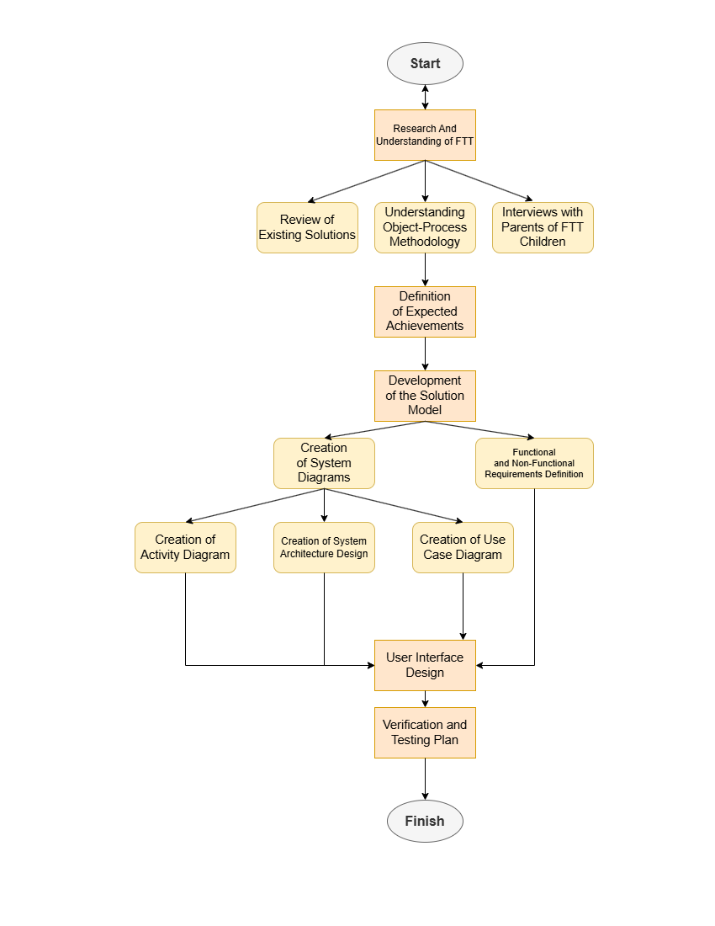
Flow diagram of the engineering process:

Interview
As part of our effort to understand the challenges faced by parents of children with growth issues, we conducted interviews with Dr. Natali Levy and Avital Shulner Tal. The goal was to gain insights into the diagnosis process, available treatments, and daily difficulties parents encounter. These discussions also explored possible solutions and support tools to improve their experience.

Dr. Natali Levy:
1. When was the child first diagnosed with FTT?
At the age of 3.
2. How did you first realize that something was wrong with the child's growth?
(Medical examination, home observation, other factors?)
At the well-baby clinic (Tipat Halav). There was a decline in weight and height percentiles.
3. Were there any early signs before the diagnosis that made you suspect something was wrong?
The child did not eat, swallowed nothing.
4. What types of treatments were offered to you? Did you choose to combine all of them?
A nutritionist and antacid medication.
5. Was the child recommended to take nutritional supplements (such as protein, zinc, vitamins)?
Yes, a high-calorie milk substitute.
- If yes, did he try to take them? If not, what were the reasons?
He drank from a baby bottle but stopped as he grew older.
6. Were there any changes in the child's diet following the diagnosis? If so, what were they?
I tried to create a high-calorie and high-protein diet for him.
7. Did the child meet with a dietitian or nutrition specialist? If so, how did it impact your daily routine?
Yes, for two years. I prepared meals according to the menu provided by the dietitian.
8. How many hours, on average, does the child sleep at night?
9 hours.
9. Does the child engage in physical activity? If so, what types of sports is he willing to do?
- If not, what do you think prevents him from doing so?
Fitness training. He doesn't want to do activities that are too difficult.
10. Have you used any apps, websites, or digital tools to manage the child's treatment? If so, how did they help you?
No, I haven’t tried them.
11. What functions or features would you expect to find in a digital system that assists with FTT management?
Tracking percentile changes, recommendations to encourage appetite.
12. Would you consider using a digital system that requests periodic updates on the child's condition?
Yes.
13. If you could receive personalized recommendations through a digital system, what kind of information would you want to get from it?
The child's current percentiles, dietary recommendations.
14. What barriers or concerns do you have regarding using such a system?
That it might make incorrect calculations or provide inaccurate recommendations.

Avital Shulner Tal:
1. When was the child first diagnosed with FTT?
At the age of 3 weeks.
2. How did you first realize that something was wrong with the child's growth? (Medical examination, home observation, other factors?)
Medical examination.
3. Were there any early signs before the diagnosis that made you suspect something was wrong?
Yes – lack of willingness to eat, no weight gain.
4. What types of treatments were offered to you? Did you choose to combine all of them?
Follow-up at an eating clinic, medical examinations, use of a feeding tube – all were combined in different stages.
5. Was the child recommended to take nutritional supplements (such as protein, zinc, vitamins)? If yes, did they try to take them? If not, what were the reasons?
Provided with calorie-enriched adapted food.
6. Were there any changes in the child's diet following the diagnosis? If so, what were they?
No.
7. Did the child meet with a dietitian or nutrition specialist? If so, how did it impact your daily routine?
Weekly meetings, created a burden but was worth it.
8. How many hours, on average, does the child sleep at night?
10-11 hours.
9. Does the child engage in physical activity? If so, what types of sports is the child willing to do? If not, what do you think prevents them from doing so?
No (a 2.9-year-old girl).
10. Have you used any apps, websites, or digital tools to manage the child's treatment? If so, how did they help you?
No.
11. What functions or features would you expect to find in a digital system that assists with FTT management?
Food diary, tracking of medical measurements and tests.
12. Would you consider using a digital system that requests periodic updates on the child's condition?
Yes.
13. If you could receive personalized recommendations through a digital system, what kind of information would you want to get from it?
I don't know.
14. What barriers or concerns do you have regarding using such a system?
Privacy of medical information.

5.2 Product
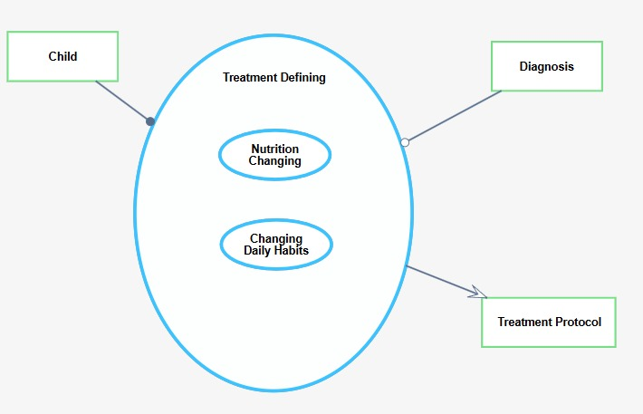

Figure 1 – Treatment Defining
The Treatment Defining process takes input from two key sources: the Child's profile and the diagnosis of their condition. The process is divided into two main sub-processes: Nutrition Changing, which focuses on adjusting the child’s diet to meet their specific nutritional needs, and Changing Daily Habits, which addresses lifestyle modifications necessary for improving the child's overall health. Based on the information gathered and analyzed during these steps, a Treatment Protocol is generated, providing personalized recommendations to support the child's growth and development. This protocol combines both dietary adjustments and habit changes to ensure a holistic approach to managing the child's condition.

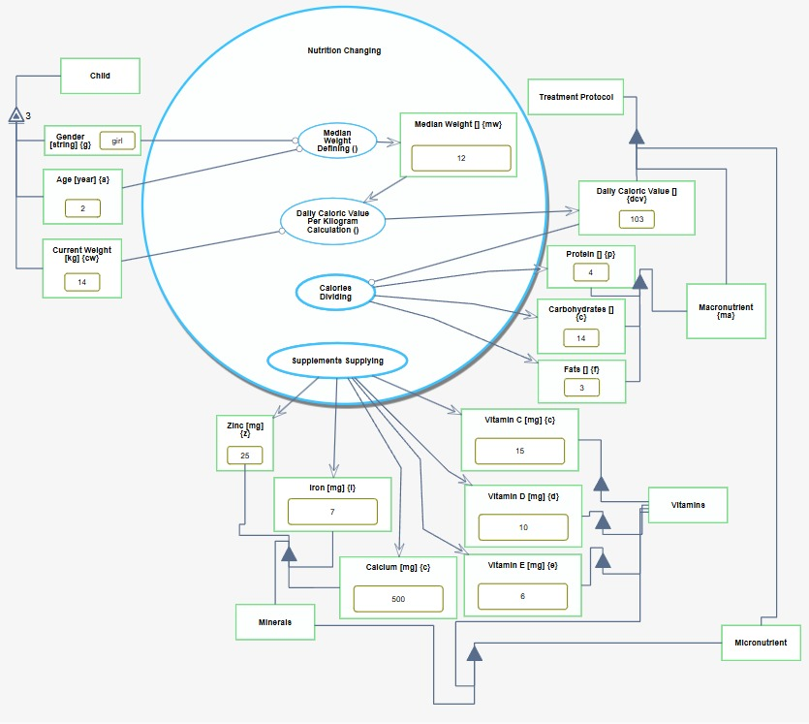

Figure 2 – nutrition changing
The Nutrition Changing process focuses on calculating a child’s daily caloric needs and providing personalized nutritional recommendations.
The process begins by receiving essential input data, including the child’s gender, age, and current weight. Based on this information, the system defines the median weight for the child’s demographic and calculates the daily caloric value per kilogram required for healthy growth.
The median weight defining in Figure 2 is done by translating the weight tables [‎16][‎17][‎18][‎19] to TypeScript code. Figure 3 exemplifies the calculation of the median weight (mw).



Figure 3. median weight calculation TypeScript code.
The daily caloric value per kilogram calculation in Figure 2 is done by the following formula:
[1]
The total caloric intake is then divided into the three main macronutrient groups: protein, carbohydrates, and fats, ensuring a balanced diet. Additionally, the system calculates the necessary micronutrients and supplements, such as zinc, iron, calcium, and vitamins.
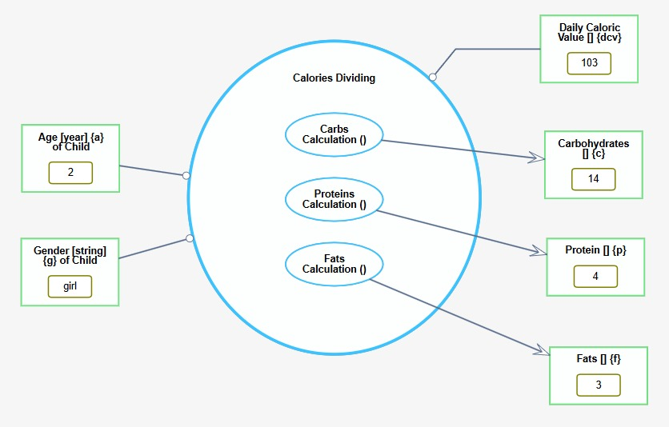

Figure 4. Calories Dividing.

The Carbohydrates calculation in Figure 4 is done by the following formula:

The carbohydrates intake formula calculates the amount of daily carbohydrates a child needs by allocating 55% of the total daily caloric value (DCV) to carbohydrates. Since each gram of carbohydrates provides 4 calories, the formula divides the caloric portion by 4 to convert it into grams. This ensures the child receives an adequate carbohydrate intake to meet energy needs.
The Proteins calculation in Figure 4 is done by the following formula:

The proteins intake formula assigns 15% of the DCV to proteins, reflecting the recommended proportion in a balanced diet. Like carbohydrates, each gram of protein provides 4 calories, so the formula divides the protein calories by 4 to determine the required grams. This ensures sufficient protein intake for growth and tissue repair.
The Fats calculation in Figure 4 is done by the following formula:

The fats intake formula calculates the required daily fat intake by allocating 30% of the DCV to fats. Since fats are more energy-dense, providing 9 calories per gram, the formula divides the fat portion by 9 to convert calories into grams. This helps ensure an appropriate intake of essential fats for energy and overall health.
The output of this process is a comprehensive treatment protocol that consolidates all the information gathered throughout the entire assessment and treatment process. It provides tailored recommendations to meet the child's unique nutritional needs, covering macronutrient and micronutrient intake, caloric adjustments, supplement suggestions, and ongoing monitoring to ensure sustained growth and optimal development.

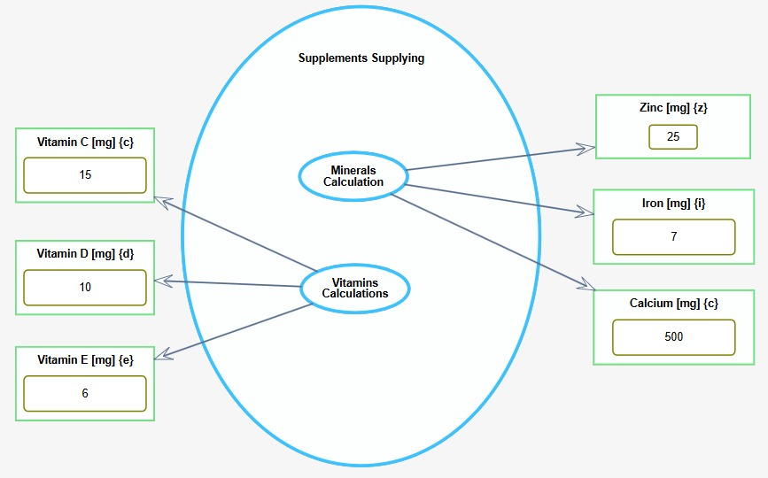

Figure 5. Supplements Supplying.
The Supplements Supplying process involves calculating the required intake of minerals and vitamins based on the child’s nutritional needs. The process begins with the Minerals Calculation, which includes determining appropriate amounts of Zinc, Iron, and Calcium. Each mineral is adjusted according to the child's age and gender.
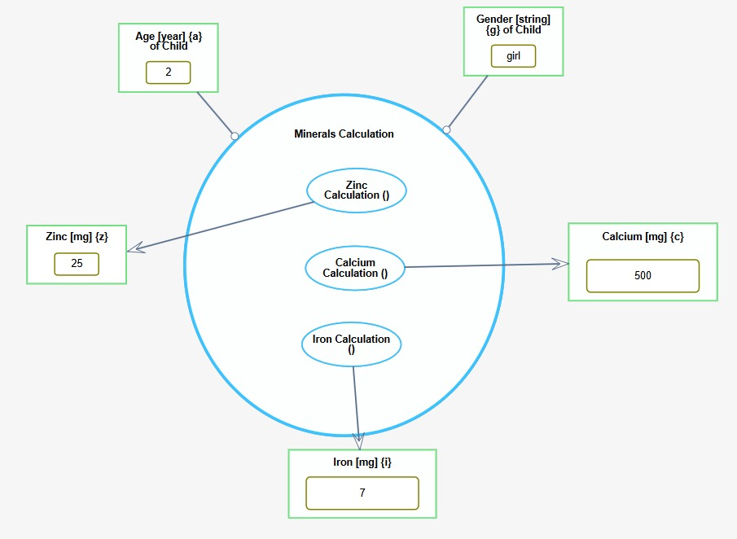

Figure 6. Minerals Calculation.
Iron is essential for oxygen transport, growth, and brain development. Children need 7-15 mg/day depending on age. Deficiency can cause anemia, fatigue, and delayed growth. Sources include meat, fish, legumes, and fortified cereals [‎20]​.
Calcium is crucial for bone and teeth health, muscle function, and nerve signaling. Daily intake ranges from 500-1300 mg. Key sources are dairy, leafy greens, and fortified plant-based milk [20]​.
Zinc is essential for growth, immune function, and cell repair. Deficiency can impair growth and increase infection risk. The article recommends up to 25 mg/day of zinc to promote growth, especially in children with recurrent illnesses like diarrhea or pneumonia [‎1].
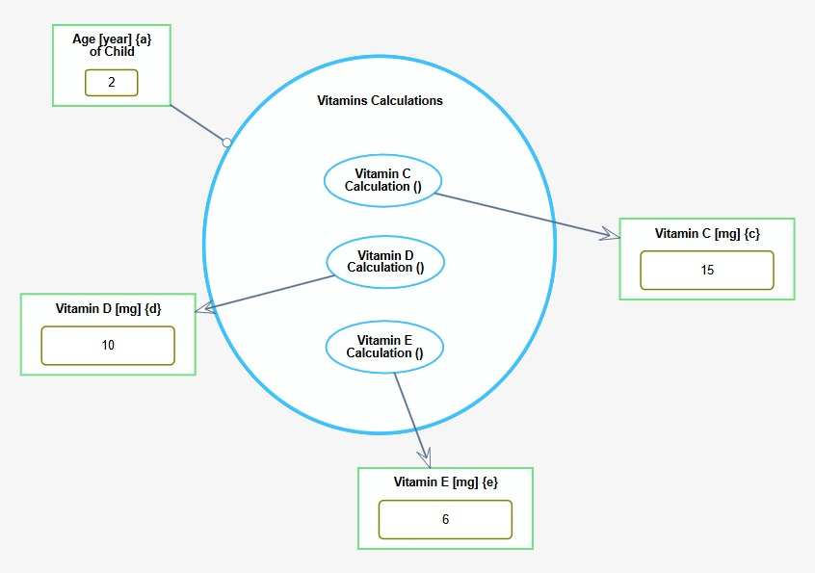

Figure 7. Vitamins Calculations.
Similarly, the Vitamins Calculation determines the necessary intake of Vitamin C, Vitamin D, and Vitamin E, ensuring that recommendations are age-appropriate.
Vitamin C supports children’s growth by promoting collagen synthesis, essential for healthy connective tissues like skin, bones, and blood vessels. It also boosts the immune system and aids in iron absorption, reducing the risk of anemia [‎20].
Vitamin D is crucial for bone development in children by aiding calcium and phosphate absorption. It prevents rickets and promotes healthy bone growth. Children with insufficient sun exposure or dietary intake are at risk of deficiency [‎20].
Vitamin E acts as an antioxidant, protecting cells from oxidative damage. It supports immune function and helps maintain healthy skin and eyes in children. Deficiency is rare but can cause neurological issues and impaired immune responses [20].
The system validates each input to ensure accurate supplement recommendations, addressing any discrepancies to avoid inappropriate dosages. This process ensures the child receives the right balance of essential nutrients for healthy development.

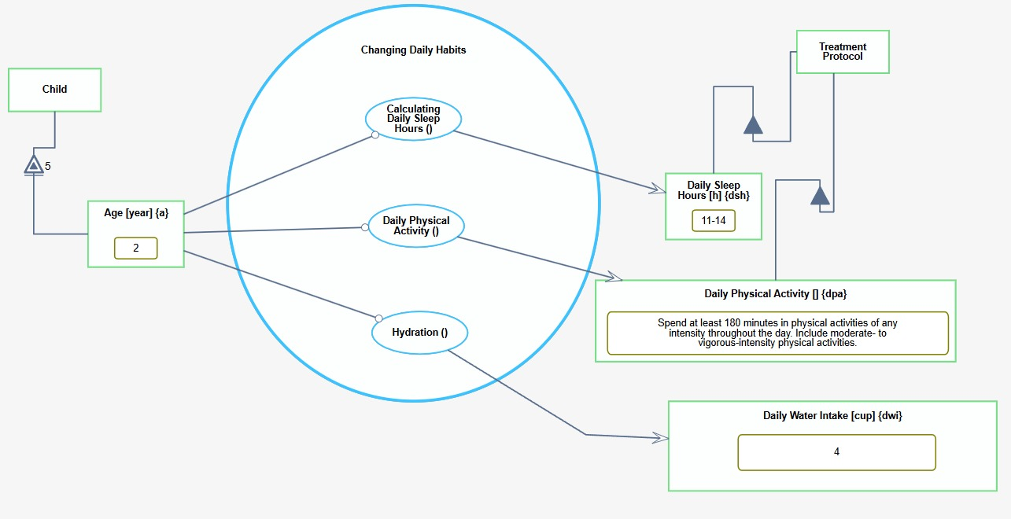
Figure 8. Changing Daily Habits.
The Changing Daily Habits process adjusts a child's lifestyle to support their overall health and development based on their age. It includes three key sub-processes: Calculating Daily Sleep Hours, Daily Physical Activity, and Hydration. These adjustments are integrated into the Treatment Protocol, promoting balanced lifestyle habits that contribute to the child's growth and well-being.
Sleep plays a vital role in children's growth and development by promoting physical, mental, and emotional well-being. During sleep, the body releases growth hormones, which are essential for bone, tissue, and muscle development. Adequate sleep supports brain function, enhancing memory, learning, and emotional regulation. It also strengthens the immune system, reduces stress, and aids in maintaining a healthy weight. Children aged 4-12 months need 12-16 hours of sleep daily, while those aged 1-2 years require 11-14 hours, 3-5 years need 10-13 hours, and 6-12 years require 9-12 hours to ensure optimal growth [‎21].
Regular physical activity is essential for children’s growth and development, contributing to stronger bones, muscles, and better motor skills. It supports cognitive development, emotional well-being, and cardiovascular health [‎22].
For infants aged 0, it is recommended to spend at least 30 minutes in tummy time throughout the day while awake. Children aged 1 to 2 years should spend at least 180 minutes in physical activities of any intensity throughout the day, including moderate- to vigorous-intensity physical activities. For children aged 3 to 4 years, it is advised to accumulate at least 180 minutes of physical activities spread throughout the day, ensuring at least 60 minutes of moderate- to vigorous-intensity physical activity. Children aged 5 to 11 years should engage in at least 60 minutes of moderate- to vigorous-intensity physical activity daily, incorporating muscle-strengthening activities at least three days per week. At age 12, children should participate in activities such as running, swimming, and team sports, including muscle- and bone-strengthening activities three times a week [‎22].
Water is essential for children's growth, supporting cell function, nutrient transport, and tissue development. Proper hydration helps maintain energy levels and promotes healthy physical and cognitive growth. Inadequate water intake can slow growth and affect overall well-being​ [‎23].
Children's water intake needs vary by age. Infants (age 0) primarily meet their water needs through 3-4 cups of breast milk or formula. Children aged 1 to 3 years are recommended to consume 4 cups of water daily. Children aged 4 to 8 years should drink 6 cups of water per day, and children aged 9 to 12 years should aim for 8 cups of water daily. Adequate hydration is essential to support children's growth and overall health [23].

Functional Requirements
- The system will allow users to create an account.
- The system will allow users to log in securely.
- The system will allow users to reset their password if forgotten.
- The system will allow users to securely log out of their account.
- The system will automatically log out inactive users after a set period of time.
- The system will allow users to view a list of children they have added.
- The system will allow users to add a new child.
- The system will allow users to upload diagnostic files for a child.
- The system will allow users to select a specific child to view or manage their details.
- The system will display growth charts for weight and height.
- The system will show both actual and target values in the growth charts.
- The system will allow users to update physical measurements for their children.
- The system will generate personalized treatment plans for each child.
- The system will allow users to download the treatment plan as a document.
- The system will support file uploads using drag-and-drop or manual selection.
- The system will restrict file uploads to a maximum size of 10MB.
Non-Functional Requirements
1. The system interface shall be intuitive and user-friendly, allowing easy navigation for all users.
2. The platform shall be responsive and adapt to various screen sizes, ensuring usability on desktop, tablet, and mobile devices.
3. The system shall load pages within 2 seconds under normal network conditions.
4. File uploads (up to 10MB) shall be processed within 5 seconds.
5. The system shall automatically log out inactive users after 15 minutes for security purposes.
6. The system shall ensure that all stored data remains accurate, complete, and reliable across all operations.
7. The platform shall support Windows, macOS, iOS, and Android, ensuring consistent functionality across different operating systems.

5.2.1 UML Diagrams
Use case diagram
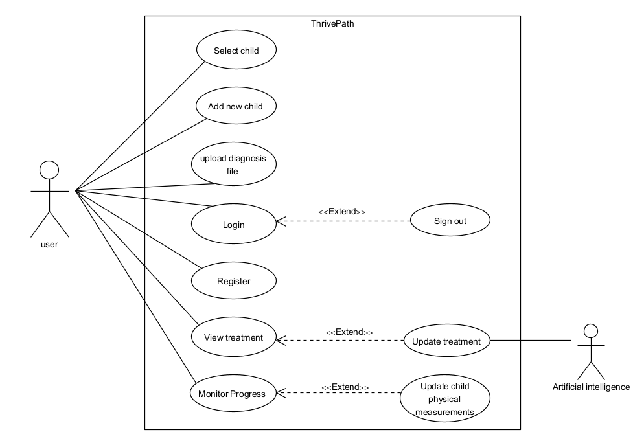

Activity diagram
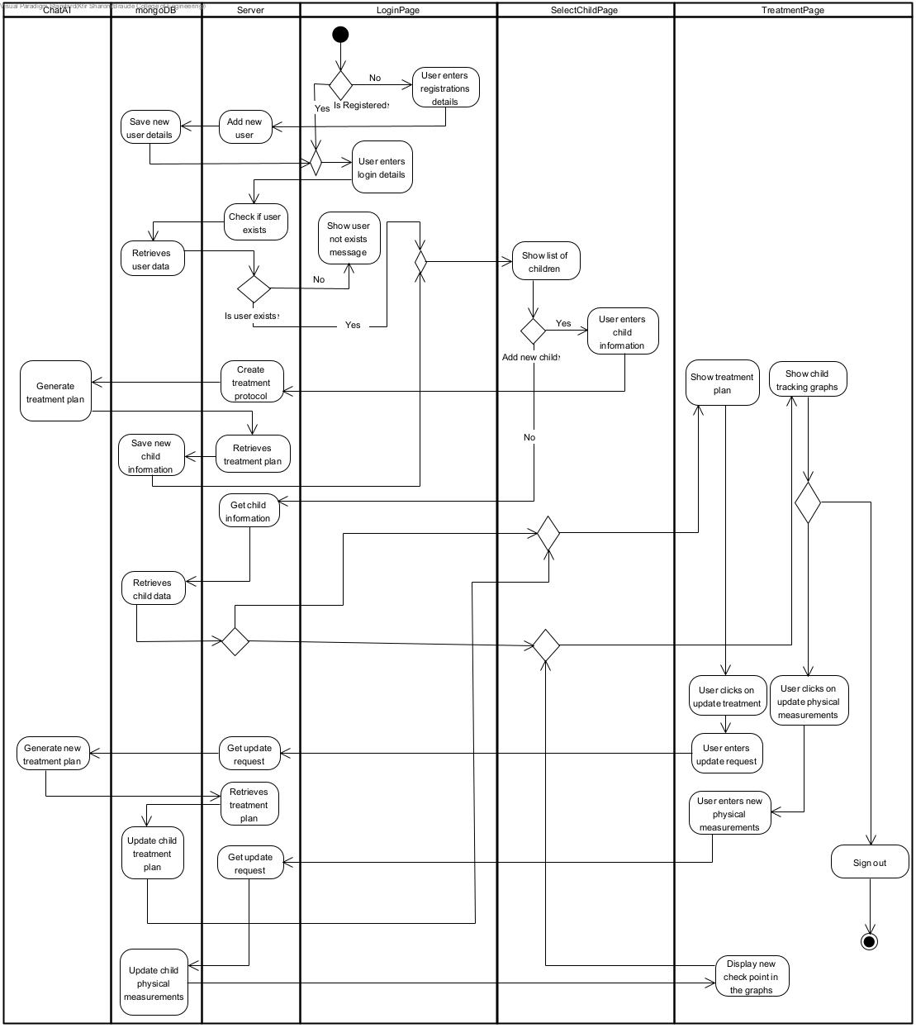

5.2.2 System Architecture Overview
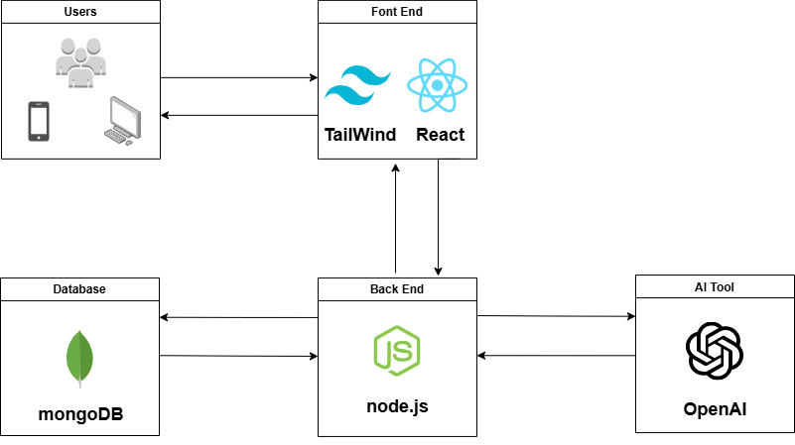
Figure 1. Architecture diagram.
The platform will be developed using a modern, full-stack architecture consisting of four key components: front-end, back-end, database, and an AI tool. This structure will ensure that the platform is scalable, efficient, and capable of providing personalized, evidence-based recommendations for families managing Failure to Thrive (FTT).
Front-End Layer
The front-end will be developed using React, a popular JavaScript library for building dynamic and interactive user interfaces. To ensure a clean and responsive design across devices, the platform will utilize Tailwind CSS, which will simplify styling and ensure visual consistency. The front-end will collect user input, send requests to the back-end via APIs, and display actionable insights in a user-friendly format.
Back-End Layer
The back-end will be developed with Node.js, an efficient server-side runtime environment that will handle data processing, user authentication, and communication between the front-end, database, and AI tool. It will manage core logic and ensure secure, reliable data transmission using an API structure.

Database Layer
The platform will use MongoDB, a database that will provide flexible storage for user profiles, medical histories, and personalized recommendations. MongoDB will allow for fast data retrieval and scalability, ensuring the system can accommodate a growing user base and evolving data needs.
AI Tool Integration
A key feature of the platform is the integration of OpenAI, which enhances personalization by generating dynamic recommendations based on user input and best practices. The AI tool processes data through the back-end to provide tailored suggestions, including meal plans, lifestyle adjustments, and developmental activities.

5.2.3 Prototype


Login Page, users are greeted with a welcome message and prompted to enter their username and password to log into the system. Additional options include a "Keep me logged in" checkbox, a link to reset a forgotten password, and a registration link for new users. The user can log in by clicking the "Log in" button.



Registration Page, users are prompted to create an account by entering a username, email, password, and confirming the password. After filling out the details, they can click the "Register" button to complete the process. A link at the bottom allows users who already have an account to log in.

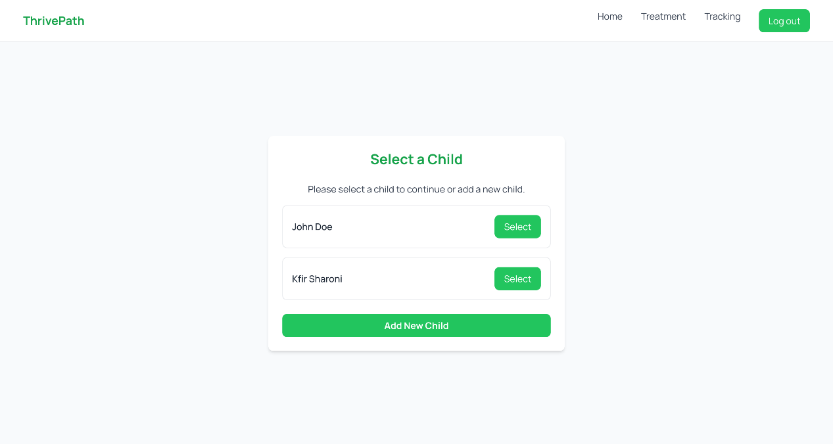
Child selection page, once the user logs into the system, they are prompted to select a child to continue or have the option to add a new child.

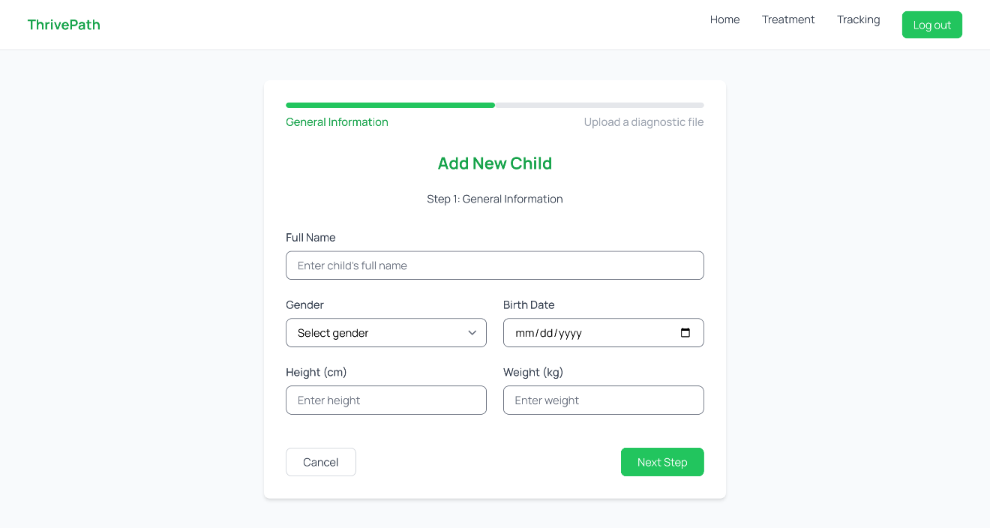

Add New Child Page, the user is prompted to fill out the general information for a new child. This includes the child's full name, gender, birth date, height, and weight. The user can proceed to the next step by clicking the "Next Step" button or cancel the action.
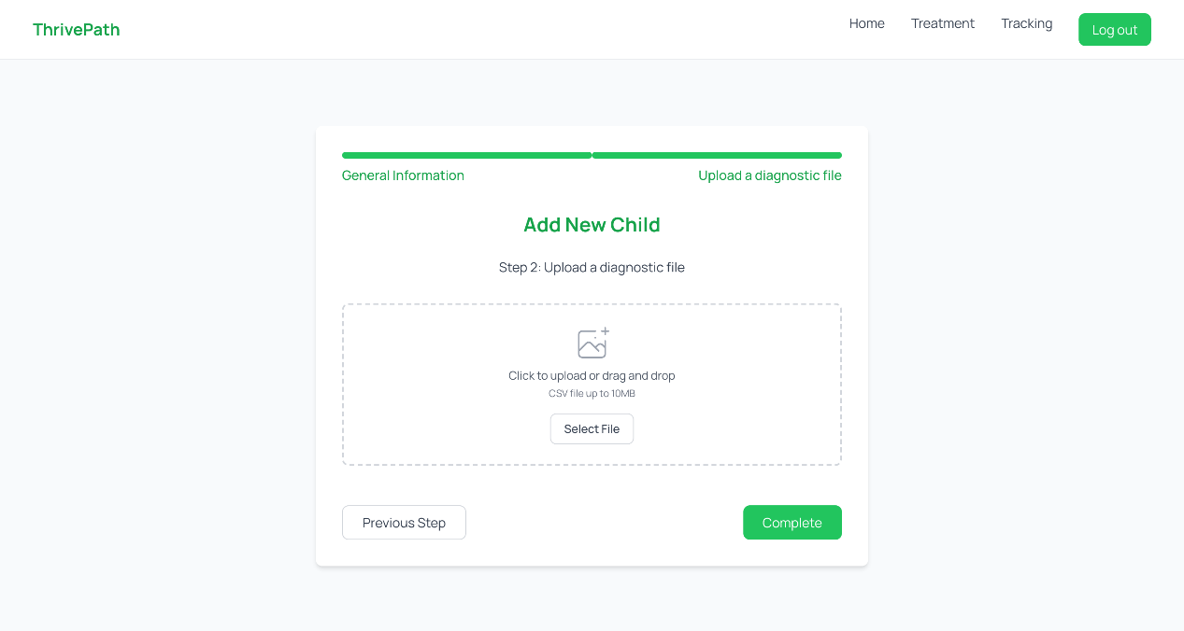

Add Diagnostic File Page, as part of adding a new child, users are prompted in Step 2 to upload a diagnostic file. They can either drag and drop the file or click the "Select File" button. Users have the option to go back to the previous step using the "Previous Step" button or complete the process by clicking the "Complete" button.

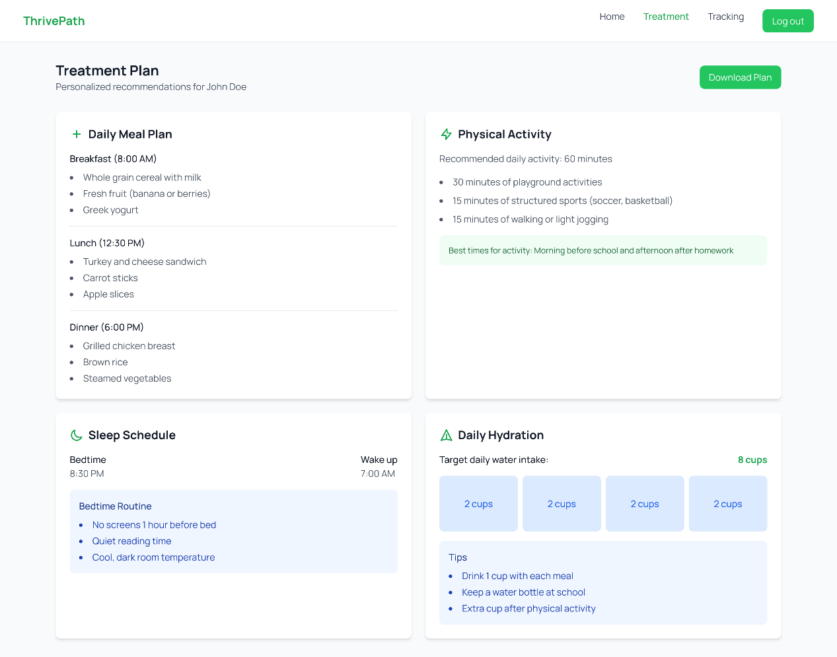

The Treatment Plan, page provides personalized recommendations for the selected child, including a daily meal plan with suggested meals, physical activity guidelines, a sleep schedule with bedtime and wake-up times, and hydration goals. Each section includes practical tips, and users can download the plan for convenience.
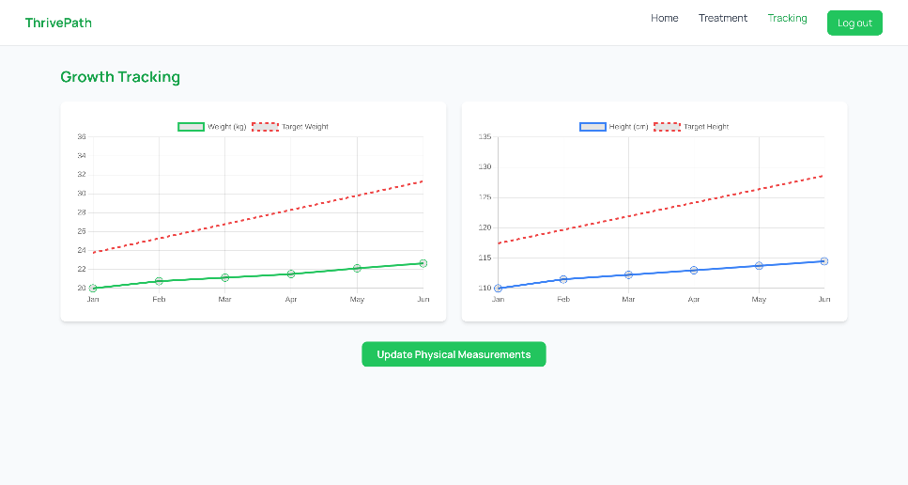

Growth Tracking Page: This page displays graphs tracking the child's weight and height progress compared to their target values over time. The weight graph (in green) and height graph (in blue) allow users to monitor progress from January to June. An "Update Physical Measurements" button lets users input updated measurements for accurate tracking.

6. Verification plan
Case | Test Case | Expected Result
1 | Login with valid credentials | The user should be successfully logged in and redirected to the child selection page.
2 | Login with invalid credentials | An error message should appear, informing the user of incorrect username or password.
3 | Register with valid inputs | The user should be successfully registered and redirected to the login page.
4 | Register with missing or invalid inputs | An error message should appear, specifying the required fields or validation errors.
5 | Select an existing child | The user should be redirected to the treatment plan or tracking page for the selected child.
6 | Add a new child with valid details | The child should be added to the system, and the user should proceed to the next step to upload a diagnostic file.
7 | Add a new child with invalid or incomplete details | An error message should appear, specifying the required fields or validation issues.
8 | Upload a valid diagnostic file | The file should be uploaded successfully, and the user should be redirected to the child selection page or the next relevant screen.
9 | Upload an invalid diagnostic file | An error message should appear, informing the user of the file requirements.
10 | View the treatment plan for a child | The treatment plan should display the personalized recommendations, including meal plan, physical activity, sleep schedule, and hydration.
11 | Download the treatment plan | The treatment plan should be downloaded as a file in a readable format.
12 | View growth tracking data | The system should display graphs for weight and height progress compared to target values.
13 | Update physical measurements | The system should allow the user to input updated measurements, and the graphs should refresh to reflect the new data.

7. Expected challenges
- Data Interpretation: Processing diagnostic files requires developing algorithms to extract key information efficiently. The system must intelligently identify critical data points while maintaining high accuracy. Advanced parsing techniques will be essential to interpret the data consistently.
- AI integration: Integrating with AI models demands robust strategies for seamless communication and recommendation generation. The system must effectively leverage existing AI capabilities to provide actionable guidance across different scenarios. Ensuring computational efficiency and output quality is crucial.
- Data security: Implementing comprehensive data protection involves advanced encryption and strict security protocols. The system must safeguard sensitive information while providing transparent data management. Continuous security monitoring will be key to maintaining user trust.
- User trust: Building credibility requires creating a transparent, user-friendly platform with clear recommendation explanations. The system must provide intuitive interfaces and implement feedback mechanisms. Empowering users with comprehensible insights will establish the platform's reliability

8. Use of AI Tools
In this project, we mostly used Google Scholar for academic research, but we also used ChatGPT and Claude to deepen our understanding and clarify complex topics, and Grammarly to ensure clarity and accuracy in our writing.
Prompt:
"Can you help me understand the medical definition of FTT?"
To establish a clear and accurate definition of FTT as the basis for designing a system that meets the clinical and practical needs of children with this condition.
Prompt:
"What is the difference between organic and inorganic FTT?"
To differentiate between the medical and non-medical causes of FTT, enabling us to create a system that addresses both physical and environmental factors.
Prompt:
"How exactly does FTT affect the families of the children?"
To understand the emotional, social, and financial challenges faced by families, ensuring our system supports not only the child but also their caregivers.
Prompt:
"What are the tools used today to treat FTT?"
To identify current methods and tools for treating FTT, allowing us to incorporate and enhance these approaches within our system.
Prompt:
"Can you help me think of interview questions for a parent dealing with a child who suffers from FTT?"
To design meaningful interview questions that gather actionable insights from caregivers, helping us tailor the system to their real-world needs and experiences.

9. REFERENCES:
- Schwartz, I. D. (2000). Failure to thrive: an old nemesis in the new millennium. Pediatrics in review, 21(8), 257-264.‏
- Cole, S. Z., & Lanham, J. S. (2011). Failure to thrive: an update. American family physician, 83(7), 829-834.‏
- Kuczmarski, R. J. (2000). CDC growth charts: United States (No. 314). US Department of Health and Human Services, Centers for Disease Control and Prevention, National Center for Health Statistics.‏
- Levi-Soskin, N., Shaoul, R., Kohen, H., Jbara, A., & Dori, D. (2019). Model-based diagnosis with FTTell: Assessing the potential for pediatric failure to thrive (FTT) during the perinatal stage. In Information Systems: Research, Development, Applications, Education: 12th SIGSAND/PLAIS EuroSymposium 2019, Gdansk, Poland, September 19, 2019, Proceedings
- Mei, Z., Grummer-Strawn, L. M., Thompson, D., & Dietz, W. H. (2004). Shifts in percentiles of growth during early childhood: analysis of longitudinal data from the California Child Health and Development Study. Pediatrics, 113(6), e617-e627.‏
- Mehta, N. M., Corkins, M. R., Lyman, B., Malone, A., Goday, P. S., Carney, L., ... & American Society for Parenteral and Enteral Nutrition (ASPEN) Board of Directors. (2013). Defining pediatric malnutrition: a paradigm shift toward etiology‐related definitions. Journal of Parenteral and Enteral Nutrition, 37(4), 460-481.
- Fox, J., Johns, N., & Rahmanzadeh, A. (1998). Disseminating medical knowledge: the PROforma approach. Artificial intelligence in medicine, 14(1-2), 157-182.‏
- Guo, C., Fu, Z., Zhang, Z., Ren, S., & Sha, L. (2018). Design verifiably correct model patterns to facilitate modeling medical best practice guidelines with statecharts. IEEE Internet of Things Journal, 6(4), 6276-6284.‏
- Guo, C., Ren, S., Jiang, Y., Wu, P. L., Sha, L., & Berlin, R. B. (2016, April). Transforming medical best practice guidelines to executable and verifiable statechart models. In 2016 ACM/IEEE 7th International Conference on Cyber-Physical Systems (ICCPS) (pp. 1-10). IEEE.‏
- Izhar, M., Naqvi, S. A. A., Ahmed, A., Abdullah, S., Alturki, N., & Jamel, L. (2023). Enhancing Healthcare Efficacy Through IoT-Edge Fusion: A Novel Approach for Smart Health Monitoring and Diagnosis. IEEE Access, 11, 136456-136467.‏
- Iyenghar, P., Gracic, E., & Pawelke, G. (2024). A Systematic Approach to Enhancing ISO 26262 with Machine Learning-Specific Life Cycle Phases and Testing Methods. IEEE Access.‏
- Paruthi, S., Brooks, L. J., D'Ambrosio, C., Hall, W. A., Kotagal, S., Lloyd, R. M., ... & Wise, M. S. (2016). Recommended amount of sleep for pediatric populations: a consensus statement of the American Academy of Sleep Medicine. Journal of clinical sleep medicine, 12(6), 785-786.‏
- World Health Organization. (2019). Guidelines on physical activity, sedentary behaviour and sleep for children under 5 years of age. World Health Organization.‏
- Lipnowski, S., LeBlanc, C. M., Canadian Paediatric Society, & Healthy Active Living and Sports Medicine Committee. (2012). Healthy active living: Physical activity guidelines for children and adolescents. Paediatrics & child health, 17(4), 209-210.‏
- Chouraqui, J. P., Thornton, S. N., Seconda, L., & Kavouras, S. A. (2022). Total water intake and its contributors in infants and young children. British Journal of Nutrition, 128(3), 531-541.‏
- Weight-for-age BOYS Birth to 5 years (percentiles)
- Weight-for-age GIRLS Birth to 5 years (percentiles)
- 2to20years:Girls Stature Weight-for-agepercentiles
- 2 to 20 years: Boys Stature-for-age and Weight-for-age percentiles
- Martini, L., Pecoraro, L., Salvottini, C., Piacentini, G., Atkinson, R., & Pietrobelli, A. (2020). Appropriate and inappropriate vitamin supplementation in children. Journal of nutritional science, 9, e20.‏
- Paruthi, S., Brooks, L. J., D'Ambrosio, C., Hall, W. A., Kotagal, S., Lloyd, R. M., ... & Wise, M. S. (2016). Recommended amount of sleep for pediatric populations: a consensus statement of the American Academy of Sleep Medicine. Journal of clinical sleep medicine, 12(6), 785-786.‏
- World Health Organization. (2019). Guidelines on physical activity, sedentary behaviour and sleep for children under 5 years of age. World Health Organization.‏
- Chouraqui, J. P., Thornton, S. N., Seconda, L., & Kavouras, S. A. (2022). Total water intake and its contributors in infants and young children. British Journal of Nutrition, 128(3), 531-541.
- Levi‐Soskin, N., Marwedel, S., Jbara, A., & Dori, D. (2024). Enhancing conceptual models with computational capabilities: A methodical approach to executable integrative modeling. Systems Engineering.‏‏

